
SRM Institute of Science and Technology
Mode of Exam
OFFLINE
College of Engineering and Technology
School of Computing
DEPARTMENT OF COMPUTATIONAL INTELLIGENCE
SRM Nagar, Kattankulathur – 603203, Chengalpattu District, Tamilnadu
Academic Year: 2024-2025 (ODD) SET - B
Test: CLAT-1 Date: 14.06.24
Course Code & Title: 18AIE424T- ARTIFICIAL INTELLIGENCE AND INTERNET OF THINGS
Duration: 50 minutes
Year & Sem: IV & VII Max. Marks: 25

Course Articulation Matrix:

S.No. | Course Outcome | PO1 | PO2 | PO3 | PO4 | PO5 | PO6 | PO7 | PO8 | PO9 | PO10 | PO11 | PO12
1 | CO1 | H | - | - | H | H | - | - | - | M | L | - | H
2 | CO2 | - | - | - | - | - | - | - | - | - | - | - | -
3 | CO3 | - | - | - | - | - | - | - | - | - | - | - | -
4 | CO4 | - | - | - | - | - | - | - | - | - | - | - | -
5 | CO5 | - | - | - | - | - | - | - | - | - | - | - | -

Part - A
( 5 x 1 = 5 Marks)
Instructions: Answer all
Q. No | Question | Marks | BL | CO | PO | PI Code
1 | Which layer in the IoT Reference Model handles data analytics and business intelligence?  - Device Layer  - Communication Layer  - Processing Layer  - Application Layer | 1 | 1 | 1 | 1,4 | 1.4.1
2 | Big Data in IoT is characterized by:  - Small data sets  - High volume, velocity, and variety of data  - Data isolation  - Limited data analytics | 1 | 1 | 1 | 1 | 1.4.1
3 | In the context of IoT, what does MQTT stand for?  - Message Queue Telemetry Transport  - Multi Query Transmission Technology  - Mobile Query Transfer Tool  - Machine Queue Transfer Technique | 1 | 1 | 1 | 1 | 1.3.1
4 | Which of the following is not a layer in the IoT reference model?  - Perception layer  - Network layer  - Application layer  - Presentation layer | 1 | 1 | 1 | 1 | 1.3.1
5 | How many layers are in the IoT reference model?  - 4  - 7  - 6  - 8 | 1 | 1 | 1 | 1 | 1.3.1
Part – B
( 5 x 2 = 10 Marks)
Instructions: Answer any 2
6 | What are the steps in data mining and how are they used in IoT? | 5 | 1 | 1 | 1 | 2.1.1
7 | With a neat diagram, explain in detail about the layers in IoT architecture. | 5 | 2 | 1 | 1,5 | 2.1.1
8 | What are services provided by IoT platform to integrate the sensors and devices? Explain different IoT platforms available in the global market to perform analytics on the cloud | 5 | 1 | 1 | 1 | 2.1.1
PART – C
(10 x 1 =10 Marks)
Instructions: Answer any 1
9 | Describe the file formats that can be used to read, save, and process data that is collected from IoT systems. | 10 | 2 | 1 | 1,5 | 2.3.1
10 | Explain how the combination of IoT, big data, and AI may help us create a better world using an example. | 10 | 3 | 1 | 1,4 | 2.3.1

*Performance Indicators are available separately for Computer Science and Engineering in AICTE examination reforms policy.

Course Outcome (CO) and Bloom’s level (BL) Coverage in Questions

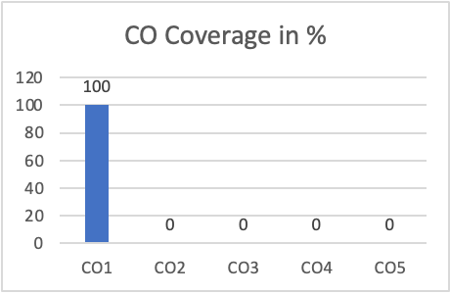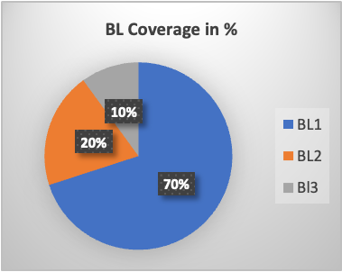

Approved by the Audit Professor/Course Coordinator

